**CAPSTONE PROJECT**

**WEATHER ANALYSIS**

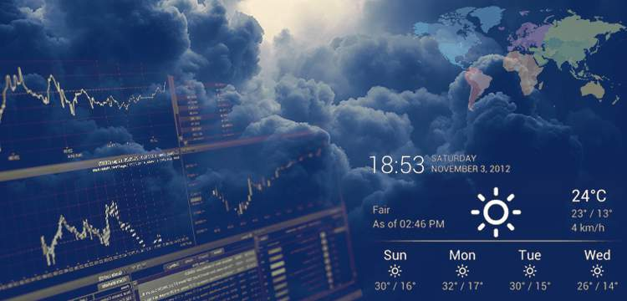

* **JHANSI GUNJA**

**INDEX**

|  |  |
| --- | --- |
| **CONTEXT** | **PAGE NUMBER** |
| Over View | 1 |
| The Process | 2-3 |
| Objectives | 4 |
| Significance | 5-6 |
| Data Dictionary | 7-10 |
| ER Diagram | 11 |
| Power BI Problem Statements | 11- 31 |
| EDA Problem Statements | 32- 68 |

**OVER VIEW**

The capstone project, titled " **Weather Analysis**" involves a thorough exploration of weather patterns across different systems. The primary objectives include comparing various climate metrics, evaluating how different criteria influence regional weather conditions, and examining the dynamic shifts in climatic metrics over time. The project aims to delve into a detailed comparison of weather attributes and uncover relationships between them to enhance our understanding of the intricacies of weather patterns.

**THE PROCESS**

1. **Data Acquisition from GitHub:**

Retrieve the related data from GitHub respiratory provided link. Retrieve the meteorological dataset from a specified source that contains crucial information about weather patterns, encompassing diverse regions and their climatic performance across distinct meteorological systems.

1. **Data Cleaning and Transformation:**

In this phase, we focus on handling missing values, implementing data normalization procedures, and effectively managing outliers within the meteorological dataset. Dealing with missing values includes employing techniques such as imputation or exclusion based on the extent of missing data. Normalizing the data is crucial to standardize the scale of meteorological variables, ensuring equitable comparisons across diverse regions. Managing outliers involves identifying and appropriately addressing data points that significantly deviate from the overall climatic patterns, minimizing their impact on the analysis.

The Transformation of this weather analysis related data has been gone through several steps. Based on the date time common every table has been changed and the data sets has converted as per convenient to the problem statement, using SQL and Power Bi.

1. **Connection with Tools:**

Incorporating the datasets involves connecting them seamlessly with analytical tools and establishing interfaces with various data processing platforms. This integration includes linking the dataset with Power BI, MS-Excel, and SQL Workbench to ensure a smooth flow of data and accurate processing. By establishing these connections, we enable efficient data integration, allowing for comprehensive analysis and exploration of the dataset across different analytical tools.

1. **Problem Solving in Power Bi:**

Utilize Power BI's versatile visualization capabilities to address a diverse set of problem statements by employing a variety of charts and visualizations. Through detailed data manipulation and analysis, unveil crucial insights and trends that provide valuable information for making well-informed decisions.

1. **Exploratory Data Analysis (EDA):**

Conducting EDA utilizing either Excel or MySQL Workbench, the choice of which depends on the specific requirements of the analysis. The primary objective is to extract meaningful insights from the analysis and effectively utilize them for informed decision-making.

1. **Creating of Visual and Insightful Power Point Presentation (PPT):**

Creating a comprehensive and insightful PowerPoint presentation that effectively communicates the key information related to the entire problem statement. The presentation will include data relevant to the given questions, detailing the appropriate problem-solving processes. Additionally, it will encompass conclusions, insights, and other pertinent aspects of the analysis.

1. **Detailed Documentation:**

Prepare a comprehensive report that thoroughly documents the entire project lifecycle. The report should include sections covering data collection, transformation, formulation of problem statements, integration of tools, solutions developed using Power BI, insights derived from Exploratory Data Analysis (EDA), and visualizations presented in PowerPoint. This detailed documentation will provide a holistic overview of the project's progression and outcomes.

**OBJECTIVES**

The primary objective of this project is to elucidate the intricate relationships existing among various weather attributes. It aims to achieve a comprehensive understanding of weather descriptions, delve into the exploration of seasonal variations, and grasp the influences exerted by geographical factors.

The overarching objective is to unravel the interconnections within different meteorological parameters, facilitating a nuanced comprehension of how these attributes interact and influence one another. The project will undertake a detailed examination of weather descriptions, seeking to decipher the complex patterns and associations inherent in meteorological data.

Furthermore, the analysis will extend its scope to explore the temporal variations in weather conditions across seasons. By doing so, the project aims to capture the dynamic nature of weather patterns and identify trends that manifest over distinct periods throughout the year. Geography plays a pivotal role in shaping local climates and weather phenomena. Thus, the project will diligently assess the influences of geography on weather attributes. This involves scrutinizing how geographical features such as topography, proximity to water bodies, and elevation contribute to the formation of unique weather patterns in different regions.

In essence, the project aspires to go beyond mere data analysis and statistical exploration. It seeks to unravel the intricacies of weather dynamics by comprehensively understanding the relationships between attributes, decoding the nuances of weather descriptions, investigating seasonal fluctuations, and discerning the profound impact of geography on shaping diverse weather phenomena.

**Significance**

Weather analysis holds significant importance across various domains due to its wide-ranging impacts on human activities, the environment, and various industries. Some key aspects of the significance of weather analysis include:

**Agriculture:**

Farmers rely on weather forecasts and analysis to plan planting and harvesting seasons. Understanding weather patterns helps in optimizing irrigation schedules and managing crop diseases.

**Energy Sector:**

Power generation, especially in renewable energy sources like wind and solar, is influenced by weather conditions. Weather analysis helps anticipate energy demand and manage supply fluctuations.

**Transportation:**

Airlines, shipping companies, and logistics businesses depend on weather forecasts to plan routes and schedules.Severe weather warnings assist in avoiding disruptions and ensuring passenger and cargo safety.

**Disaster Preparedness**:

Weather analysis is crucial for predicting and preparing for natural disasters such as hurricanes, floods, and wildfires. Early warnings help authorities and residents evacuate and take necessary precautions.

**Healthcare:**

Certain weather conditions can impact public health, such as heatwaves, cold spells, or the spread of infectious diseases influenced by climate patterns.

Hospitals and health agencies use weather forecasts to anticipate and respond to health-related challenges.

**Construction and Infrastructure:**

Weather analysis is vital in planning construction projects, as adverse weather conditions can delay or impact construction activities. Infrastructure maintenance and durability are influenced by weather patterns.

**Tourism and Recreation:**

The tourism industry relies on weather forecasts to attract visitors and plan outdoor activities. Weather analysis helps recreational facilities plan for peak seasons and events.

**Insurance and Risk Management:**

Insurers use weather data to assess risks related to property damage, agriculture, and other areas. Accurate weather analysis aids in setting insurance premiums and managing claims.

**Environmental Conservation**:

Weather analysis contributes to monitoring and understanding climate change and its impacts on ecosystems. Conservation efforts are influenced by weather patterns affecting biodiversity and ecosystems.

**Research and Education:**

Meteorological research helps improve our understanding of climate systems and contribute to advancements in science. Weather analysis is a crucial component of educational curricula, enhancing students' understanding of Earth's dynamic processes.

In summary, weather analysis is integral to making informed decisions across diverse sectors, contributing to safety, efficiency, and sustainability in various aspects of human life and economic activities.

**DATA DICTIONARY**

**Dataset Description**

This dataset includes data on city attributes, humidity, pressure, temperature, weather descriptions, wind direction, and wind speed for various cities

**Table Explanations**

1. ***Table name - City_attributes***

**Purpose:**

This file provides metadata about each city that is covered in the dataset.

**Columns:**

City: The name of the city.

Country: The country in which the city is located.

Latitude: The geographical latitude of the city.

Longitude: The geographical longitude of the city.

**Usage:**

This file can be used to map cities to their respective countries and geographical coordinates. It can also be useful if one wants to perform location-based analysis or visualization on a map.

1. ***Table name-Humidity*:**

**Purpose**:

Contains hourly data representing the humidity levels in each city.

**Columns:**

Datetime: The specific hour for which the data is recorded.

City Columns: Each city has its own column, and under each city column, the humidity level for that hour is recorded.

**Usage:**

Useful for analysing humidity trends, understanding seasonal variations, or correlating humidity with other factors.

1. ***Table name- Pressure:***

**Purpose:**

Provides hourly data about the air pressure levels in each city.

**Columns**:

Datetime: The specific hour for which the data is recorded.

City Columns: Each city has its own column, and under each city column, the air pressure level for that hour is recorded.

**Usage:**

Can be used to study pressure patterns, predict weather changes, or understand the relationship between pressure and other weather attributes.

1. ***Table Name-Temperature***:

**Purpose:**

Contains hourly temperature data for each city.

**Columns:**

Datetime: The specific hour for which the data is recorded.

City Columns: Each city has its own column, and under each city column, the temperature for that hour is recorded.

**Usage:**

Vital for studying temperature trends, understanding heatwaves or cold spells, and correlating temperature with factors like energy consumption.

1. ***Table name - Weather_description:***

**Purpose:**

Provides a textual description of the weather for each city on an hourly basis.

**Columns:**

Datetime: The specific hour for which the data is recorded.

City Columns: Each city has its own column, and under each city column, the weather description for that hour is provided (e.g., "clear sky", "rainy", "cloudy", etc.).

**Usage:**

Useful for understanding the qualitative aspects of weather, categorizing weather types, or analysing the frequency of certain weather conditions.

1. ***Table name- Wind_direction:***

**Purpose**:

Contains data about the direction from which the wind is blowing on an hourly basis for each city.

**Columns:**

Datetime: The specific hour for which the data is recorded.

City Columns: Each city has its own column, and under each city column, the wind direction for that hour is recorded (usually in degrees).

**Usage:**

Can be used to study wind patterns, predict potential wind-related events, or understand the relationship between wind direction and other factors like pollution dispersion.

1. ***Table Name- Wind_speed:***

**Purpose:**

Provides hourly data about the speed of the wind in each city.

**Columns:**

Datetime: The specific hour for which the data is recorded.

City Columns: Each city has its own column, and under each city column, the wind speed for that hour is recorded (usually in km/h or m/s).

**Usage:**

Vital for understanding wind patterns, predicting potential wind-related hazards, or studying the impact of wind speed on various activities.

The data dictionary offers a concise summary of the dataset's architecture, outlining the significance of each field across various tables. The dataset's richness becomes evident as it adeptly captures multifaceted details concerning universities, ranking systems, and evaluation criteria. This comprehensive approach empowers analysts to conduct an in-depth examination of university success, unravelling performance trends and patterns over time.

**ER DIAGRAM**

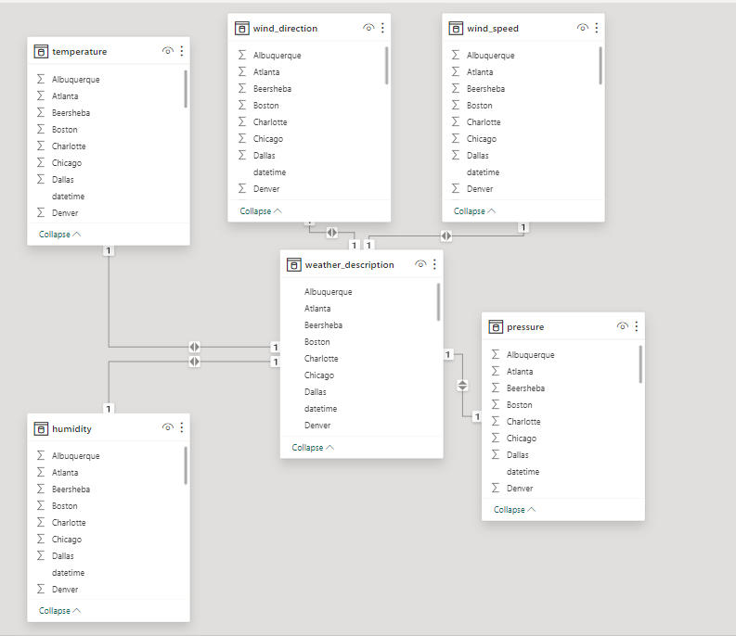

**ER DIAGRAM (Changed as per the Requirement)**

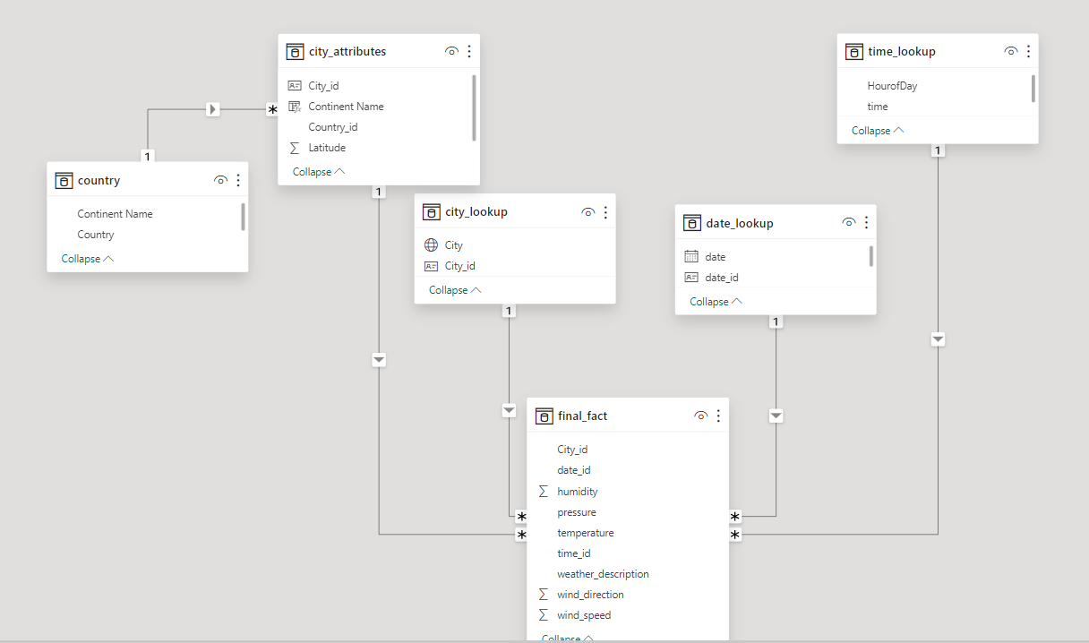

**POWERBI PROBLEM STATEMENTS**

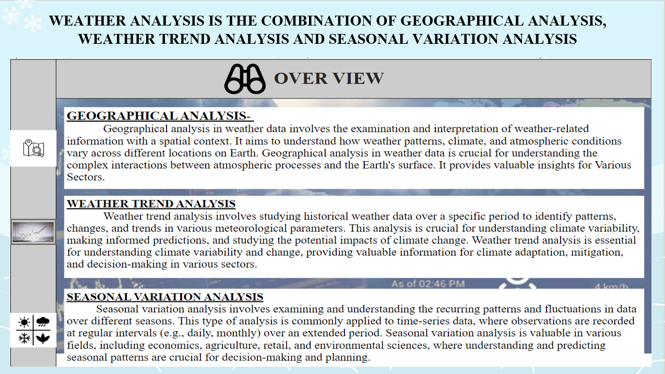

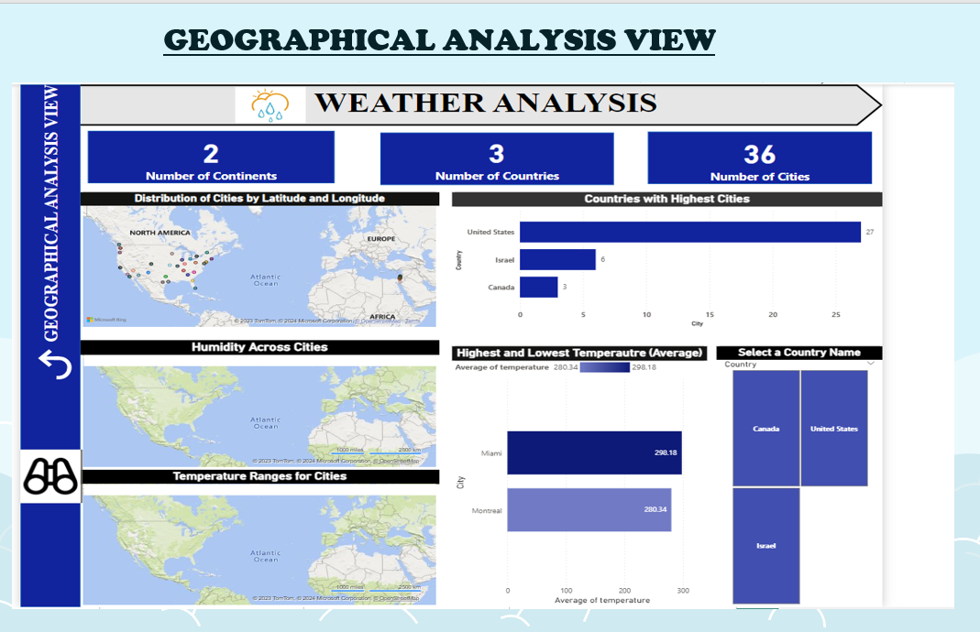

**PROBLEM STATEMENT-**

Can you create a geographical map in Power BI showing the distribution of cities in the dataset based on their latitude and longitude? (Q-1)

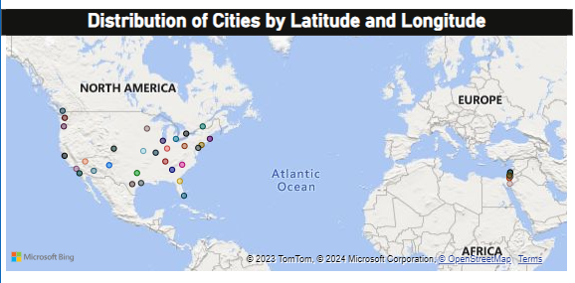

**EXPLANATION-**

The map visualization above illustrates the geographical distribution of cities based on their respective latitude and longitude coordinates. Each distinct colour on the map corresponds to a specific city. To access detailed information about a particular city, users can hover over the corresponding colour using the cursor in Power BI. This action triggers a display that provides the city's name, along with its associated latitude and longitude coordinates, offering users a clear and interactive way to explore geographical data within the visualization.

**PROBLEM STATEMENT-**

How does humidity vary across different cities? Generate a heatmap in Power BI to visualize this variation. (Q-5)

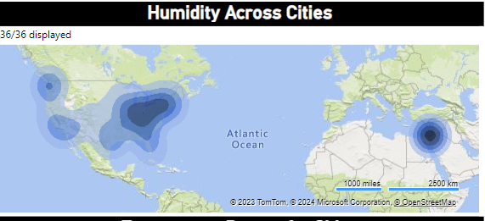

**EXPLANATION-**

The presented visual is a Heat Map depicting humidity levels across various cities. The humidity data is available on an hourly basis, showcasing potential variations across different locations. This dynamic representation allows for a detailed examination of humidity fluctuations in real-time. By zooming in on the visual within Power BI, users gain enhanced insights, enabling a more granular view of humidity patterns. This zoom functionality serves as a valuable tool to discern nuanced variations and trends, facilitating a comprehensive understanding of how humidity levels evolve across diverse cities over time.

**PROBLEM STATEMENT-**

Can you build a heatmap in Power BI to show the temperature ranges for cities across different countries? (Q-11)

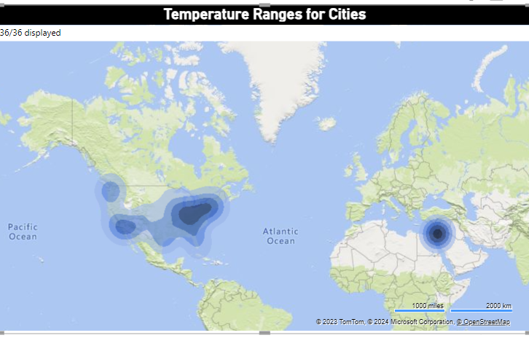

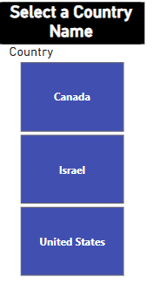

**EXPLANATION-**

The provided Heatmap Visual illustrates temperature ranges for cities distributed across various countries. Utilizing a Slicer feature, exclusive to Power BI, users can easily navigate and explore temperature data on a country-by-country basis. This interactive tool enhances the visualization by allowing users to focus on specific regions of interest, providing a comprehensive overview of temperature variations in cities across different countries. The integration of the Slicer feature adds a dynamic dimension to the analysis, enabling a more tailored and insightful exploration of temperature trends across diverse geographic locations.

**PROBLEM STATEMENT-**

In Power BI, can you create a bar chart representing the top 10 countries with the highest number of cities in the dataset? (Q-2)

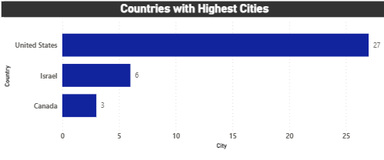

**EXPLANATION-**

The displayed chart is a bar chart showcasing the number of cities for each country. The original Question aimed to identify the top 10 countries with the highest number of cities. However, the available data reveals only three countries in the dataset. Consequently, the chart is structured to present the count of cities in descending order for each country, providing a clear visualization of the distribution. While the top 10 countries may not be applicable due to the limited dataset, the chart effectively portrays the relative city counts within the available countries, aiding in a straightforward understanding of the city distribution.

**PROBLEM STATEMENT-**

Create a bar chart in Power BI to highlight cities with the highest and lowest average temperatures in the dataset. (Q-12)

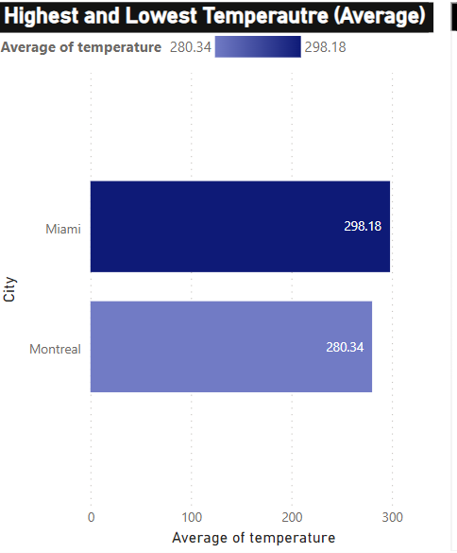

**EXPLANATION-**

The presented bar chart provides a visual representation of the highest and lowest average temperatures across all cities in the given dataset. Calculating the average temperature for each city, the chart highlights Miami with the highest average temperature of 298.18 and Montreal with the lowest average temperature of 280.34. This analysis allows for a quick and clear comparison of temperature variations, emphasizing the extremes observed in Miami and Montreal among the diverse cities included in the dataset. The visual aids in easily identifying temperature outliers and understanding the temperature range across the dataset.

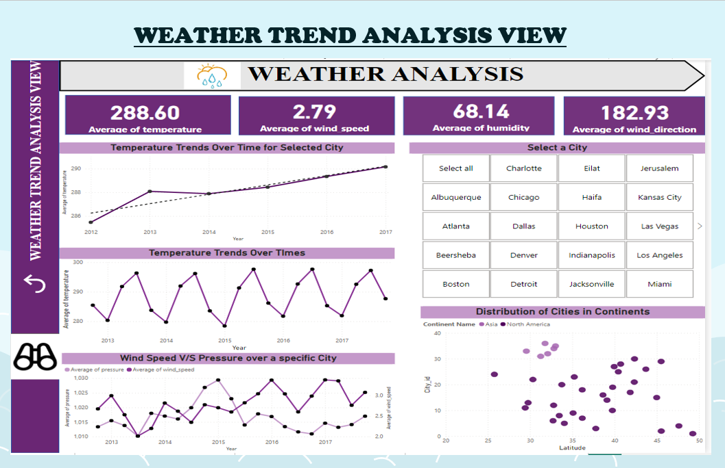

**PROBLEM STATEMENT-**

Create a line chart in Power BI to display the temperature trends over time for a selected city. Highlight extreme temperature events? (Q-4)

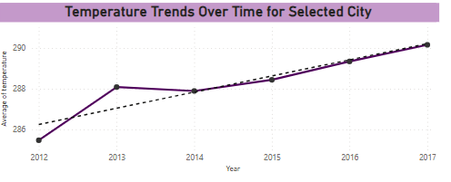

 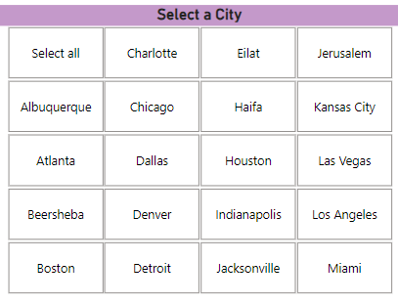

**EXPLANATION-**

The displayed line chart portrays the trends in average temperatures over time. A dotted line is incorporated as a trend line, facilitating the interpretation of the overall direction of temperature changes throughout the observed period. Notably, black dots highlight extreme temperature points, drawing attention to significant fluctuations or outliers. In the Power BI platform, users can leverage a City Slicer to discern the temperature trends specific to each city. This interactive feature enables a more detailed and customized exploration, allowing users to focus on individual cities and gain insights into their unique temperature patterns within the broader temporal context.

**PROBLEM STATEMENT-**

Create a time-series line chart in Power BI to show the overall temperature trends over the entire dataset. (Q-7)

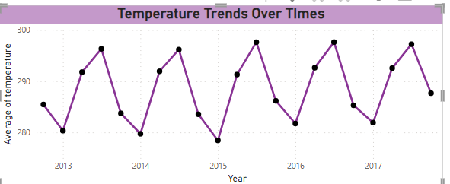

**EXPLANATION-**

The depicted time series line chart provides a comprehensive overview of the overall temperature patterns within the entire dataset. A discernible cyclic pattern is evident, with temperatures following a consistent wave-like trajectory each year. Typically, at the start of the year, temperatures are observed to be below 280, gradually increasing to levels above 290 in the middle of the year. Subsequently, there is a recurrent trend of decreasing temperatures towards the end of the year. This consistent annual oscillation suggests a recurring seasonal pattern, where temperatures exhibit a predictable rise and fall throughout the course of each year.

**PROBLEM STATEMENT-**

Can you create a time-series chart in Power BI showing the relationship between wind speed and air pressure for a specific city? (Q-6)

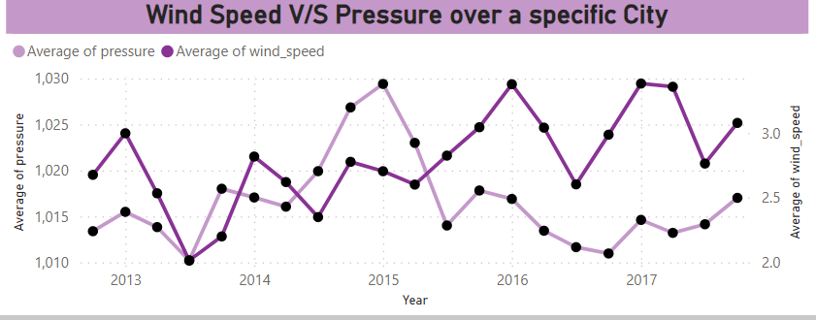

 

**EXPLANATION-**

The correlation between wind speed and air pressure over time appears to be positive, indicating that higher wind speeds are associated with larger air pressure values. This positive relationship suggests that strong winds tend to coincide with high-pressure conditions, often leading to storm-like situations. To delve deeper into the relationship between air pressure and wind speed for individual cities, the use of a Slicer in the analysis would enhance comprehension. This interactive tool allows users to selectively focus on specific cities, providing a more detailed and nuanced understanding of how the relationship between wind speed and air pressure manifests in different geographical locations.

**PROBLEM STATEMENT-**

How does the distribution of cities in terms of latitude vary across different continents? Create a scatter plot in Power BI to illustrate this? (Q-3)

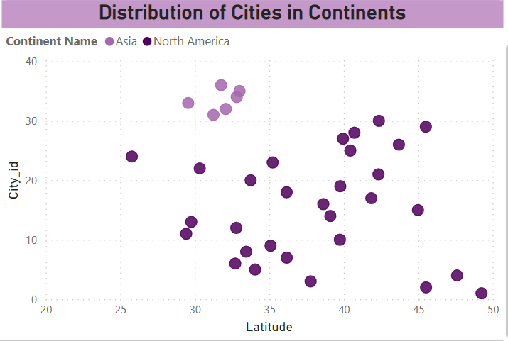

**EXPLANATION-**

The presented scatter plot visually represents the distribution of cities based on their latitude across various continents. The darker shade on the plot corresponds to cities in North America, while the lighter shade signifies cities in Asia. The varying shades indicate the diverse latitudinal positions of cities within and across these continents. The latitude values for each city exhibit a range of positions, contributing to the overall geographical diversity showcased in the plot. This visualization offers an insightful perspective on how cities are spread across continents with distinct latitudinal variations.

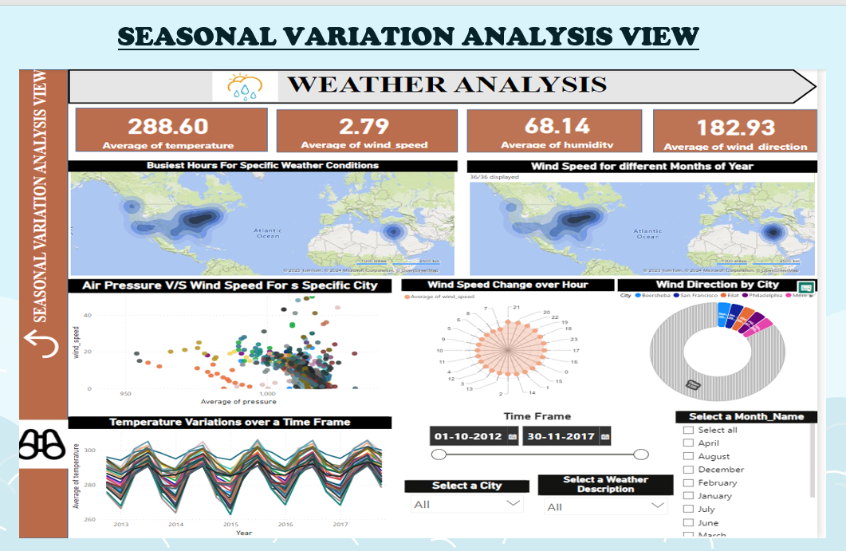

**PROBLEM STATEMENT-**

Can you create a heatmap in Power BI to visualize the busiest hours for specific weather conditions (e.g., "clear sky," "rainy")? (Q-8)

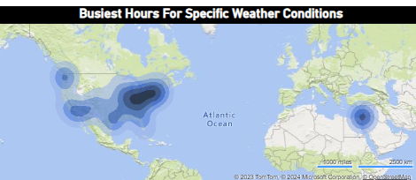

 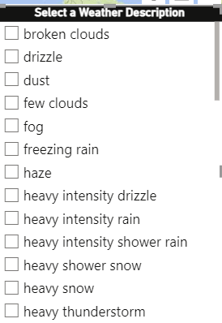

**EXPLANATION-**

The provided Heat Map offers insights into business hours corresponding to different weather conditions. To enhance clarity and meaningful exploration, users can leverage the Weather Conditions Slicer in Power BI. This interactive feature allows for a more focused analysis, enabling users to selectively view business hours based on specific weather conditions. By utilizing the slicer, individuals can customize their exploration, gaining a more nuanced understanding of how different weather conditions impact business hours. This additional layer of interactivity ensures a more targeted and insightful interpretation of the relationship between weather conditions and operational hours.

**PROBLEM STATEMENT-**

Can you generate a Power BI heatmap illustrating the average wind speeds across cities for different months of the year? (Q-14)

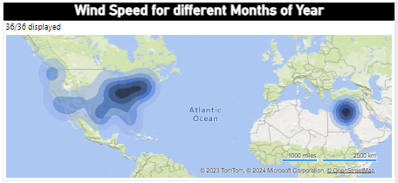

 

**EXPLANATION-**

The presented Heat Map visually conveys the wind speeds across various months of the year. To enhance the interpretability and derive more meaningful insights, users can take advantage of the Month of the Year Slicer within the Power BI platform. This interactive tool empowers users to narrow down their analysis to specific months, allowing for a more focused exploration of wind speed patterns. By utilizing the slicer functionality, individuals can customize their view, gaining a more nuanced understanding of how wind speeds vary across different months. This approach ensures a more targeted and insightful interpretation of the seasonal dynamics inherent in the relationship between wind speed and the months of the year.

**PROBLEM STATEMENT-**

Create a Power BI scatter plot to show the relationship between wind speed and air pressure for a specific city? (Q-15)

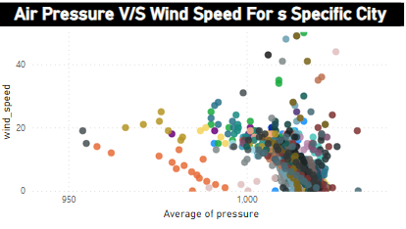

 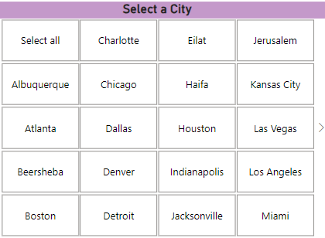

**EXPLANATION-**

The displayed chart depicts the relationship between the average wind speed and pressure across all cities. While the chart provides a general overview of the correlation among these attributes for all cities, for a more targeted analysis, users can employ the City Slicer functionality in Power BI. This interactive tool enables users to select and focus on a specific city, gaining more detailed insights into the relationship between average wind speed and pressure for that particular location. Overall, a positive relationship is observed between these attributes, signifying that, in general, higher wind speeds tend to be associated with higher air pressure. This positive correlation is a key aspect highlighted by the visualization.

**PROBLEM STATEMENT-**

Create a Power BI chart comparing the temperature variations between two selected cities over a specific timeframe? (Q-10)

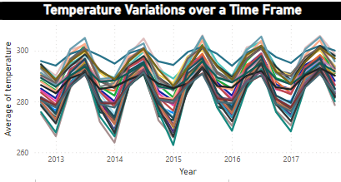

 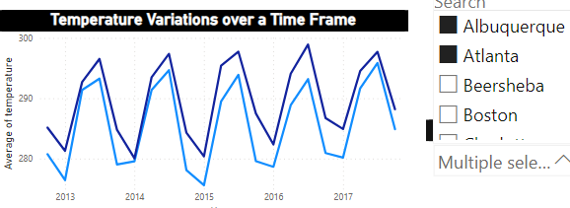

**EXAMPLE**

**EXPLANATION-**

The presented time series chart, in the form of a line chart, illustrates the temperature variations across all cities. However, for a more targeted comparison, users can utilize the City Name Slicer in Power BI. This interactive feature allows users to select and focus on two specific cities at a time. By employing the slicer, individuals can streamline their analysis, directly comparing temperature trends between the chosen cities. This approach enhances the chart's effectiveness, providing a more detailed and insightful exploration of temperature dynamics for the selected city pair.

**PROBLEM STATEMENT-**

How does the wind speed change over the course of a day? Create a radial chart in Power BI to represent this? (Q-9)

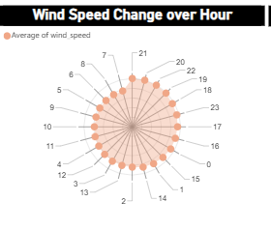

**EXPLANATION-**

The depicted chart is a radial representation showcasing the wind speed for each hour of the day in a 24-hour time format. This radial chart effectively captures the fluctuations in wind speed throughout the day, providing a comprehensive view of the hourly variations. The visual highlights the dynamic nature of wind speed changes across different hours over the years, offering insights into the temporal patterns. The circular format of the chart facilitates a clear understanding of how wind speed evolves throughout the 24-hour cycle, contributing to a more intuitive interpretation of the data.

**PROBLEM STATEMENT-**

Create a wind rose chart in Power BI to visualize the prevailing wind directions for a selected city? (Q-13)

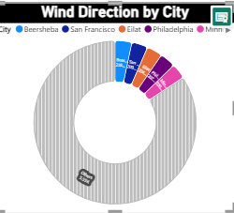

**EXPLANATION-**

The presented rose chart offers a visual representation of wind direction patterns across various cities. In this chart, the coloured slices indicate cities with higher wind directions compared to others, while the non-coloured sections represent cities with relatively lower wind directions. This visualization allows for a quick and intuitive assessment of cities that experience notable variations or strengths in wind direction. By leveraging colour differentiation, the chart effectively highlights specific cities with distinctive wind characteristics, providing a clear and insightful overview of the distribution of wind directions across the dataset.

**EDA**

**(**Exploratory Data Analysis) **PROBLEM**

**STATEMENTS**

**PROBLEM STATEMENT-**

Are there any countries with cities located at extreme latitudes, and how might this impact their climate? (Q-1)

**SQL QUERY-**

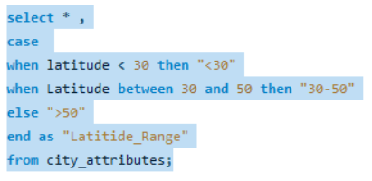

OUTPUT-

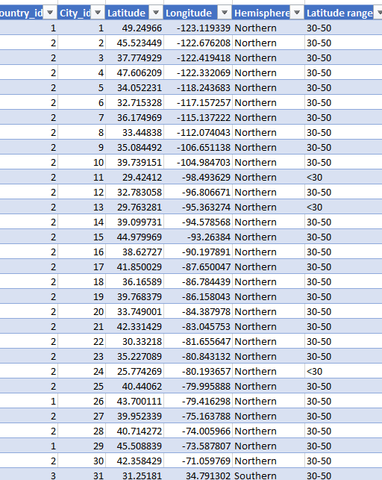

**EXPLANATION-**

Extreme latitudes refer to locations that are situated far from the equator, either toward the North Pole (in the northern hemisphere) or the South Pole (in the southern hemisphere). The equator is defined as 0 degrees latitude, and as you move towards the poles, the latitude increases. Extreme latitudes are typically associated with polar regions, which experience unique climatic conditions, including cold temperatures, polar day (continuous daylight during summer), and polar night (continuous darkness during winter).

In the list of cities you provided, none of them are located in polar regions. They are distributed across North America and Israel, regions that are closer to the equator and, therefore, experience more moderate climates. Here's why the cities in your list do not have extreme latitudes:

**PROBLEM STATEMENT-**

Can you identify any clusters of cities with similar latitude and longitude values? What factors might explain these clusters? (Q-2)

**Cluster 1: West Coast Cities**

Vancouver

Portland

San Francisco

Seattle

Los Angeles

San Diego

These cities are clustered along the west coast of North America, sharing similar latitudes. This geographical proximity is likely due to the coastal alignment and the climate patterns associated with the Pacific Ocean.

**Cluster 2: Southwestern U.S. Cities 7. Las Vegas**

Phoenix

Albuquerque

These cities are situated in the southwestern United States and are characterized by relatively high temperatures and arid climates. They form a cluster due to their geographic proximity and similar environmental conditions.

**Cluster 3: Texas Cities 10. Denver**

Dallas

Houston

These cities are part of the state of Texas, and their clustering may be influenced by the state's large size and diverse geography. Texas has a variety of climates, including coastal areas, plains, and mountains.

**Cluster 4: Midwest Cities 14. Kansas City**

Minneapolis

Saint Louis

Chicago

Nashville

Indianapolis

These cities are located in the central part of the United States, often referred to as the Midwest. They share a common region and experience similar seasonal variations in weather.

**Cluster 5: Eastern U.S. Cities 20. Atlanta**

Detroit

Jacksonville

Charlotte

Miami

Pittsburgh

Toronto

Philadelphia

New York

Montreal

Boston

These cities are distributed along the eastern part of North America. They form a cluster based on their proximity to the Atlantic Ocean and the shared geographical region.

**Cluster 6: Israel Cities 31. Beersheba**

Tel Aviv District

Eilat

Haifa

Nahariyya

Jerusalem

These cities are in Israel and share a relatively small geographic area, forming a cluster in the eastern Mediterranean region.

Factors explaining these clusters include geographical proximity, shared climatic conditions, and historical, cultural, or political ties. Cities in the same region often have similar environmental characteristics and may develop economic and cultural connections due to their close proximity.

**PROBLEM STATEMENT-**

Are there any correlations between a city's geographical location (latitude and longitude) and its weather attributes, such as temperature or humidity? (Q-3)

**To find out the correlation we need to find the average of each attribute using SQL**

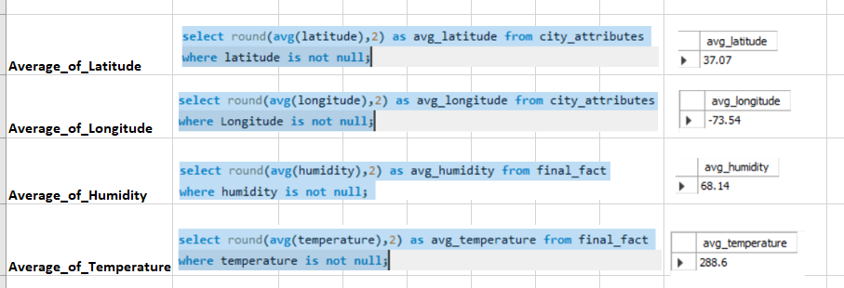

**Note- As the Data is huge which cannot be pasted in Excel, So Visualisations has been Performed in Power BI**

**Correlation between geographical location and weather attributes**

* Correlation between Latitude and Temperature

**SQL QUERY**

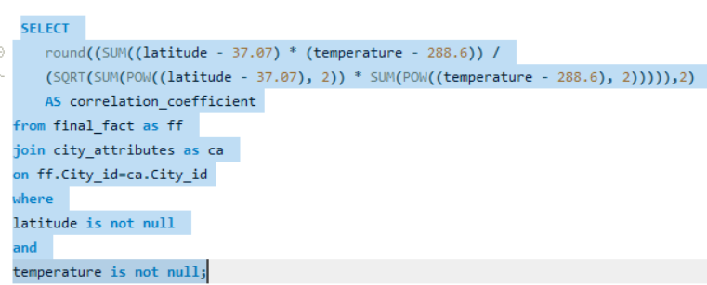

**OUTPUT**

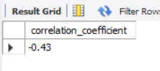

**VISUAL REPRESENTATION**

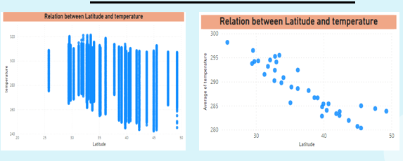

***For clear visualisation purpose, I made the y-axis as average.***

**EXPLANATION**

The data analysis reveals a negative correlation between latitude and temperature, indicating that these two variables tend to move in opposite directions. Specifically, when latitude increases, temperature tends to decrease, and conversely, when latitude decreases, temperature tends to increase. The strength of this relationship is quantified by the correlation coefficient, which, in this case, is calculated as -0.43. This coefficient value of -0.43 signifies a moderate negative correlation between latitude and temperature. In simpler terms, as you move away from the equator (higher latitude), there is a tendency for temperatures to decrease, and as you move towards the equator (lower latitude), temperatures tend to increase.

* Correlation between Latitude and Humidity

**SQL QUERY**

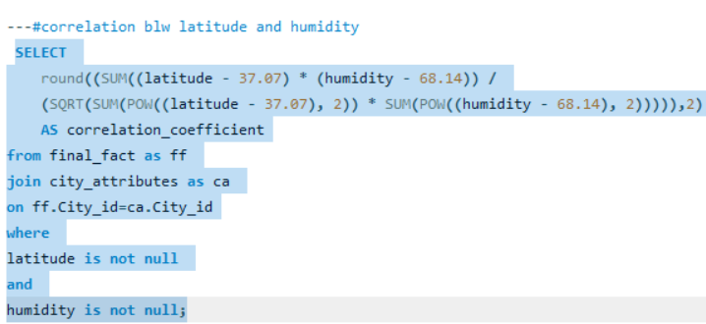

**OUTPUT**

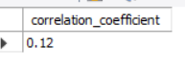

**VISUAL REPRESENTATION**

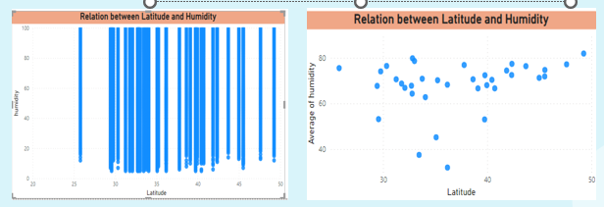

***For clear visualisation purpose, I made the y-axis as average.***

**EXPLANATION-**

The data analysis reveals a positive correlation between latitude and humidity, indicating that these two variables tend to move in the same direction. In practical terms, as latitude increases, there is a tendency for humidity to increase, and conversely, as latitude decreases, humidity tends to decrease. The strength of this relationship is measured by the correlation coefficient, which, in this instance, is calculated as 0.12. This coefficient value of 0.12 suggests a relatively weak positive correlation between latitude and humidity. Therefore, while there is a discernible trend, it is not as pronounced as in cases of stronger positive correlations. Overall, this information helps in understanding the general association between latitude and humidity levels across the dataset.

* Correlation between Longitude and Temperature

**SQL QUERY**

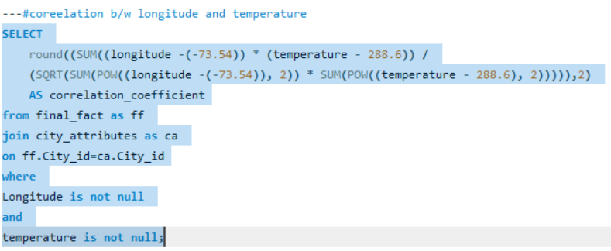

**OUTPUT**



**VISUAL REPRESENTATION**

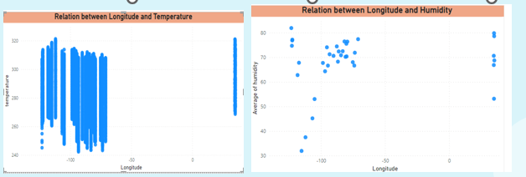

***For clear visualisation purpose, I made the y-axis as average.***

**EXPLANATION**

The data analysis reveals a positive correlation between longitude and temperature, indicating that these two variables tend to move in the same direction. In practical terms, as longitude increases, there is a tendency for temperature to increase, and conversely, as longitude decreases, temperature tends to decrease. The strength of this relationship is measured by the correlation coefficient, which, in this case, is calculated as 0.21. This coefficient value of 0.21 suggests a relatively weak positive correlation between longitude and temperature. While there is a discernible trend, the correlation is not very strong, implying that other factors may also influence temperature variations across different longitudes. Nonetheless, the positive correlation indicates a general tendency for temperature and longitude to co-vary in the dataset.

* Correlation between Longitude and Humidity

**SQL QUERY**

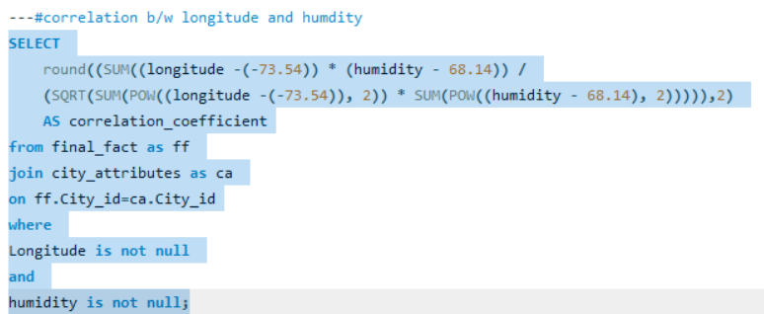

**OUTPUT**



**VISUAL REPRESENTATION**

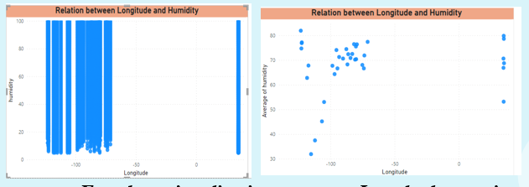

***For clear visualisation purpose, I made the y-axis as average.***

**EXPLANATION**

The data analysis indicates a positive correlation between longitude and humidity, suggesting that these two variables tend to move in the same direction. In practical terms, as longitude increases, there is a tendency for humidity to increase, and conversely, as longitude decreases, humidity tends to decrease. The strength of this relationship is quantified by the correlation coefficient, which, in this instance, is calculated as 0.07. This coefficient value of 0.07 indicates a relatively weak positive correlation between longitude and humidity. While a discernible trend exists, the correlation is not very strong, implying that other factors may also contribute to variations in humidity levels across different longitudes. Overall, the positive correlation suggests a general tendency for humidity and longitude to co-vary in the dataset.

**PROBLEM STATEMENT**

Identify the top three cities with the most frequent occurrence of rainy weather based on weather descriptions. What are the seasonal patterns? (Q-4)

**SQL QUERY**

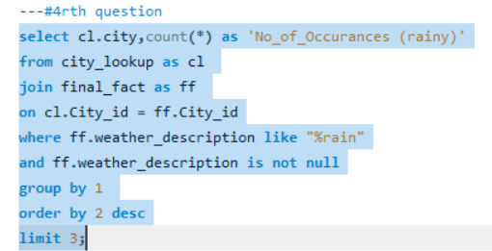

**OUTPUT**

|  |  |
| --- | --- |
| city | No_of_Occurances (rainy) |
| Portland | 10994 |
| Vancouver | 10308 |
| Seattle | 9731 |

**VISUAL REPRESENTATION**

**EXPLANATION**

The presented pie chart visually highlights the top three cities with the highest occurrences of rainy weather. Each slice of the pie represents the percentage of rainy weather within the total weather conditions for a specific city. This chart effectively communicates the distribution of rainy weather among the top three cities, offering a quick and intuitive understanding of the prevalence of rain in each city relative to the others.

**To Show the Seasonal Patterns, created a line chart using Power Bi.**

**VISUAL REPRESENTATION**

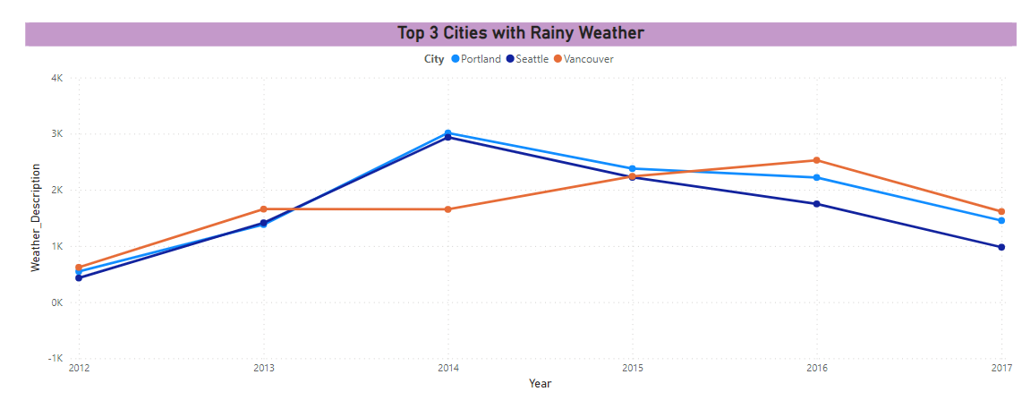

**EXPLANATION**

The observed seasonal patterns in weather data exhibit a consistent trend characterized by an increase in rainfall starting from Quarter 1, peaking in Quarter 3, and subsequently decreasing as we move into Quarter 4. This cyclical behaviour is recurring each year, indicating a repetitive and predictable sequence. The established pattern underscores the reliability of this weather phenomenon, showcasing a regular progression in rainfall throughout the quarters. This recurrence provides valuable insights into the temporal dynamics of weather conditions, aiding in the anticipation and understanding of the annual weather cycle. Certainly, the consequences and adaptations to prolonged periods of extreme cold or heat can vary based on the specific characteristics of cities and regions within the United States, Canada, and Israel.

**PROBLEM STATEMENT-**

Is there a correlation between humidity levels and air pressure? How might this relationship affect weather conditions? (Q-5)

**SQL QUERY-**

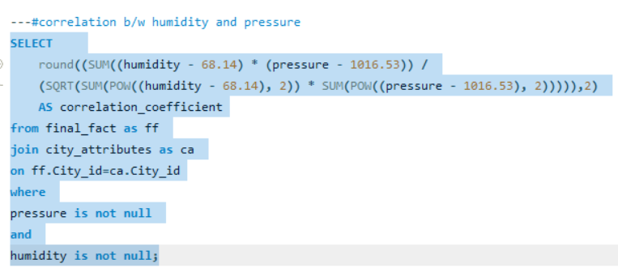

**OUTPUT-**

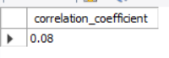

**VISUAL REPRESENTATION**

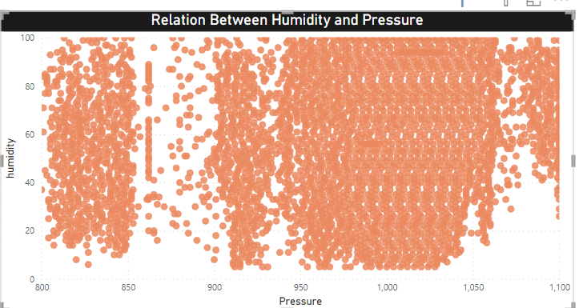

***For clear visualisation purpose, I made the y-axis as average.***

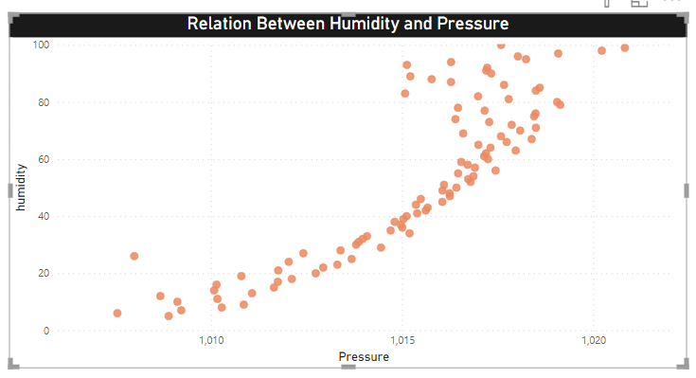

**EXPLANATION**

Here exists a positive correlation between humidity and atmospheric pressure, indicating that these two weather attributes tend to move in the same direction. When humidity increases, atmospheric pressure tends to rise simultaneously, and conversely, when humidity decreases, there is a tendency for atmospheric pressure to decrease as well.

This positive correlation implies a consistent relationship between humidity and pressure, where changes in one variable are associated with corresponding changes in the other. The atmosphere's moisture content, reflected by humidity, appears to influence the atmospheric pressure, and vice versa. It allows meteorologists and researchers to make more accurate predictions and interpretations of atmospheric conditions based on observed changes in humidity and pressure.

**Affect on Weather Conditions**

When a low-pressure system migrates into a region, it typically results in overcast skies, increased wind speeds, and precipitation. Conversely, high-pressure systems tend to bring about clear and tranquil weather conditions. The relationship between humidity and rainfall is notable, as higher humidity levels signify an augmented presence of water vapor in the air, subsequently increasing the likelihood of precipitation. Understanding these atmospheric dynamics is pivotal for weather forecasting, enabling meteorologists.

**PROBLEM STATEMENT-**

Explore the impact of wind direction on temperature for coastal cities. Are there noticeable patterns? (Q-6)

**Coastal Cities Consideration-**

Coastal cities in this list include Vancouver, Portland, San Francisco, Seattle, Los Angeles, San Diego, Houston, Miami, Philadelphia, New York, Montreal, Boston, Tel Aviv District, Eilat, Haifa, Nahariyya. Note that some cities, like Las Vegas, Phoenix, and Denver, are inland and not considered coastal.

There is no mention of Costal Cities, created the data as per rhe question requirement by segregating the cities into Costal and Non – Coastal

**SQL QUERY**

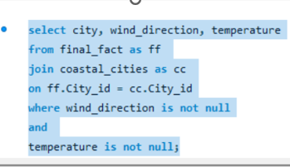

**VISUAL REPRESENGTATION**

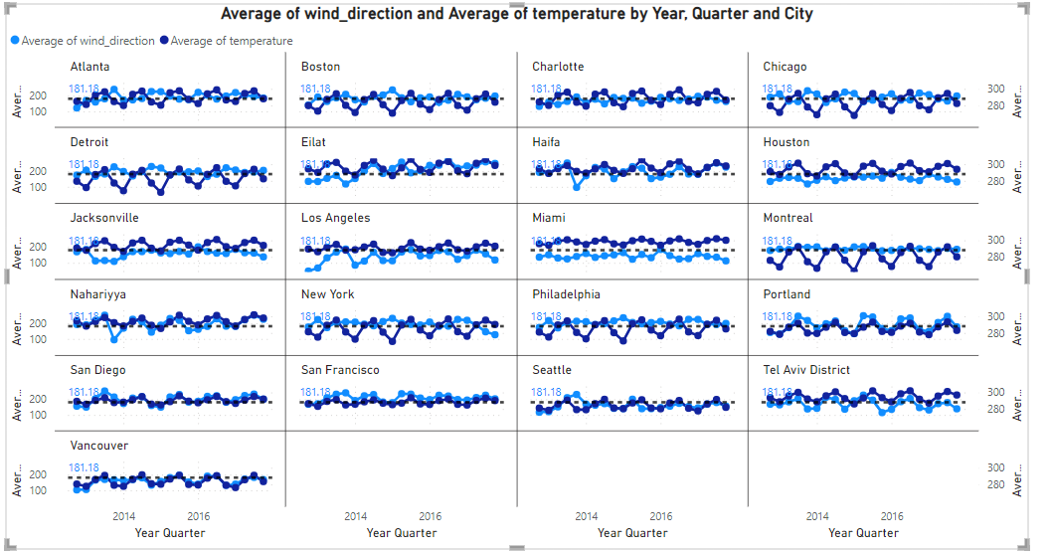

**EXPLANATION**

The influence of wind direction on temperature in coastal cities is a significant aspect shaped by several factors, including maritime effects, temperature disparities between land and sea, and local topography. Observations reveal that each coastal city exhibits its unique temperature patterns. However, a common trend across all coastal cities is the undulating movement resembling a wave, discernible through the utilization of an average line.

The distinctive temperature patterns in coastal areas are intricately linked to the proximity of large bodies of water, as maritime influences tend to moderate temperature extremes. The temperature contrasts between the land and sea contribute to the variability in local climates, impacting how wind direction influences temperatures.

The observed wave-like movement, evident when analyzing the average line, suggests a dynamic and cyclical nature in coastal temperature patterns. This phenomenon could be attributed to the rhythmic interplay of various climatic factors and geographical features along the coastlines. Understanding these patterns is crucial for residents, meteorologists, and policymakers alike, as it facilitates better preparation for and adaptation to the varying climatic conditions in coastal regions.

**PROBLEM STATEMENT-**

Are there specific months when cities experience significant temperature fluctuations? What might explain these variations? (Q-7)

**SQL QUERY**

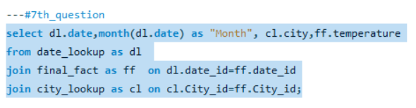

**VISUAL REPRESENTATION**

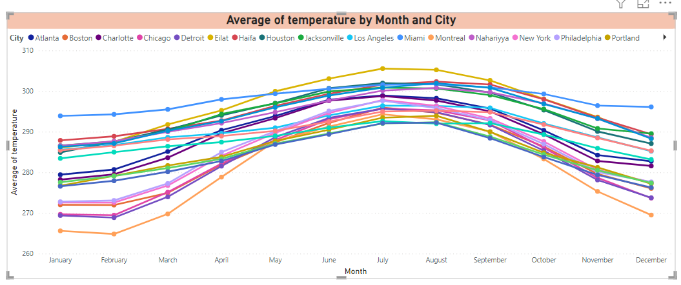

**EXPLANATION**

Temperature fluctuations

As depicted in the visual analysis, exhibit distinct patterns over the course of the year. The initial months, January and February, portray lower temperatures, establishing a baseline for the seasonal variations. Subsequently, a gradual increase in temperature is observed, with a pronounced upswing during the months of June, July, August, and September. These summer months experience a significant rise in temperatures, indicative of the warm season.

Following the peak in summer, there is a gradual decline in temperature, marking the transition into the autumn months. The decrease becomes particularly notable in December, signaling the arrival of winter. The visual representation underscores the cyclical nature of temperature changes throughout the year, showcasing a recurring pattern of rising and falling temperatures corresponding to the changing seasons.

Understanding these temperature fluctuations is essential for various sectors, including agriculture, energy management, and public health, as it allows for informed planning and decision-making based on the anticipated climatic conditions, providing valuable insights into the seasonal temperature trends observed over the analysed period.

Variations Explanations

The temperature variations observed each month offer a concise depiction of the dynamic changes in climate throughout the year. These fluctuations serve as a temporal record, highlighting the cyclical progression of seasons. The gradual temperature rise in spring and summer, followed by a decline in fall and winter, mirrors the typical seasonal transitions. This information is crucial for sectors such as agriculture and tourism, enabling effective planning and resource management in response to the inherent patterns of climate change. The concise analysis of monthly temperature variations provides valuable insights into the cyclical nature of climate shifts, aiding in understanding and adapting to seasonal changes.

**PROBLEM STATEMNT-**

Identify periods of extreme weather events, such as storms or heatwaves, by analysing the time-based data. What patterns emerge? (Q-8)

As there are no things like mentioned as storms or heatwaves in the given data. So, I assume that dragging the values that can be seen similar with the storms. I would like to consider the following. They are

1. Broken_Clouds
2. Scatter Cloud
3. Thunderstorm with Heavy
4. Heavy Intensity Rain
5. Volcanic ash

**SQL QUERY**

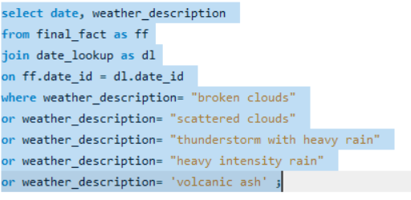

**VISUAL REPRESENTATION**

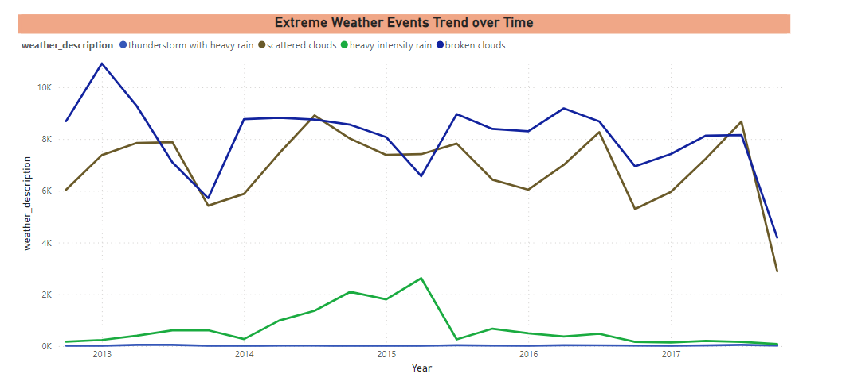

**EXPLANATION**

**There are Different Patterns for Storms.**

* Scattered clouds and broken clouds consistently exhibit a distinct pattern of high intensity storms. Throughout the years, there is a recurring sequence where their intensity begins at a medium level, gradually increases in the middle of the year, and then slowly decreases towards the year's end. This consistent yearly pattern underscores the dynamics of storm intensity for both scattered and broken clouds.
* Heavy intensity rain shows a noteworthy surge in occurrences specifically in the year 2015. Subsequently, it maintains a steady and constant presence throughout each subsequent year. This indicates a sustained and heightened frequency of heavy intensity rain events since 2015.
* Thunderstorms accompanied by heavy rain remain infrequent, registering a value of 0 for most of the observed period. This suggests that such storms are rare, occurring sporadically over the years, and their frequency has been minimal.
* Volcanic ash occurrences are sporadic, happening only once in specific years: 2013, 2015, and 2017, as per the available data. This infrequent appearance of volcanic ash events underscores their rarity, manifesting only occasionally throughout the observed period.

**PROBLEM STATEMNT-**

Are there any notable differences in temperature trends between northern and southern hemisphere cities over the year? How do they relate to seasons? (Q-9)

There is no required data for hemisphere added a column with hemisphere

**VISUAL REPRESENTATION**

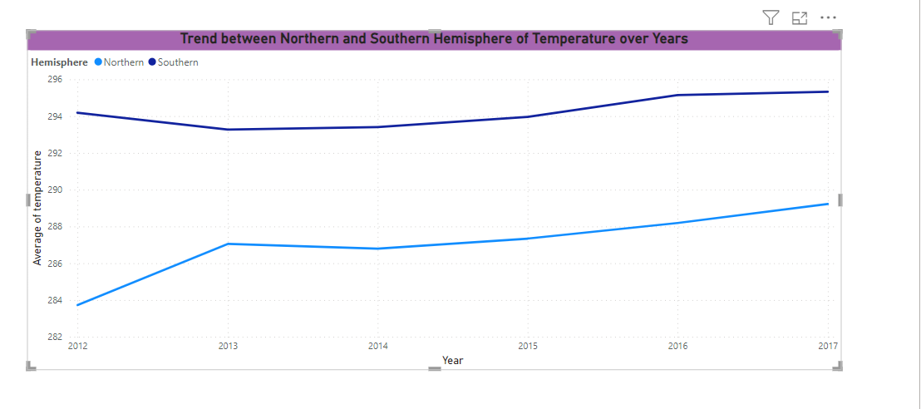

**EXPLANATION**

Trend’s Between Hemisphere’s

In the Northern Hemisphere, December 2012 recorded a notably low average temperature. Examining the annual temperature trend, it indicates a consistent or slightly rising pattern throughout the year, with a gradual increase observed each subsequent year. This temperature trend appears to be mirrored in Southern Hemisphere cities as well.

A noteworthy distinction emerges when comparing the average temperatures between the two hemispheres. The Southern Hemisphere exhibits higher average temperatures compared to the Northern Hemisphere. Consequently, this leads to a scenario where Southern Hemisphere cities experience higher temperatures, while Northern Hemisphere cities tend to have lower average temperatures. The observed patterns emphasize the inter-hemispheric temperature differences and their implications on the overall climate. Understanding these trends is crucial for comprehensive climate analysis and aids in predicting and adapting to the diverse temperature patterns experienced in different hemispheres.

Relate to Seasons-

The analysis of temperature patterns between the Northern and Southern Hemispheres provides valuable insights that can be correlated with seasonal variations. During the summer season, the average temperature differences between the hemispheres may not be as pronounced. However, in other seasons, distinctive variations become more apparent.

In seasons other than summer, a notable difference in average temperatures is observed between Southern Hemisphere cities, which tend to experience higher temperatures, and Northern Hemisphere cities, where average temperatures are relatively lower. This discrepancy underscores the influence of hemispheric location on the seasonal climate experienced by cities.

**PROBLEM STATEMENT-**

What are the consequences of prolonged periods of extreme cold or heat in specific cities? How do residents adapt to such conditions? (Q-10)

Generally, for this type of questions, Theoretically Answers will justify more. Certainly, the consequences and adaptations to prolonged periods of extreme cold or heat can vary based on the specific characteristics of cities and regions within the United States, Canada, and Israel.

**United States:**

* Extreme Cold:

Northeast (e.g., New York, Boston):

Consequences: Heavy snowfall can lead to transportation disruptions, school closures, and power outages.

Adaptations: Residents use snow removal equipment, winter clothing, and heating systems.

Midwest (e.g., Chicago, Minneapolis):

Consequences: Subzero temperatures can lead to frozen pipes, car issues, and health risks.

Adaptations: Insulation in homes, car maintenance, and layered clothing are common adaptations.

Northern Plains (e.g., Fargo):

Consequences: Extremely low temperatures, wind chill, and potential livestock issues.

Adaptations: Heated shelters for animals, winterizing homes, and outdoor activity restrictions.

* Extreme Heat:

Southwest (e.g., Phoenix, Las Vegas):

Consequences: High temperatures can lead to heat-related illnesses, stress power grids, and increase water demand.

Adaptations: Extensive use of air conditioning, water conservation measures, and heat safety awareness.

Southeast (e.g., Miami, Atlanta):

Consequences: High humidity exacerbates the heat, increasing the risk of heat-related illnesses.

Adaptations: Air conditioning, hydration measures, and urban planning for shade and cooling.

**Canada:**

* Extreme Cold:

Prairie Provinces (e.g., Winnipeg):

Consequences: Severe cold, wind chill, and potential for frozen infrastructure.

Adaptations: Well-insulated homes, block heaters for cars, and winter-specific clothing.

Northern Territories (e.g., Yellowknife):

Consequences: Extremely low temperatures, limited daylight, and challenges in transportation.

Adaptations: Specialized winter equipment, snowmobiles, and communal support systems.

* Extreme Heat:

Southern Ontario (e.g., Toronto):

Consequences: High temperatures, increased demand for electricity, and potential strain on infrastructure.

Adaptations: Air conditioning, water conservation, and emergency response plans.

West Coast (e.g., Vancouver):

Consequences: Uncommon but rising instances of heatwaves leading to health risks.

Adaptations: Cooling centers, community support, and awareness campaigns during heatwaves.

**Israel:**

* Extreme Heat:

Coastal Areas (e.g., Tel Aviv):

Consequences: Hot and dry conditions, increased risk of wildfires.

Adaptations: Water conservation, air conditioning, and firefighting measures.

Negev Desert (e.g., Beersheba):

Consequences: Extremely high temperatures, limited water resources.

Adaptations: Desert-friendly architecture, water-saving technologies, and heat-resistant agriculture.

* Extreme Cold:

Israel generally experiences milder winters, but elevated areas like Jerusalem can see occasional snowfall.

Adaptations: Residents may use heating systems during colder periods, but extreme cold is less common.

In all these regions, public awareness, government intervention, and community support systems are crucial for residents to adapt to and mitigate the impacts of prolonged periods of extreme weather conditions.

**PROBLEM STATEMNT-**

Investigate whether temperature anomalies (unusual deviations from the norm) coincide with certain events or environmental factors in specific cities? (Q-11)

**SQL QUERY**

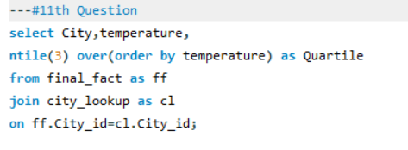

**OUTPUT**

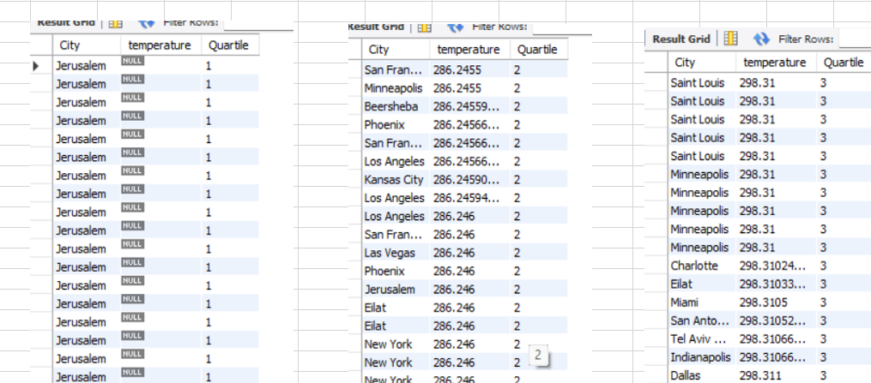

**PROBLEM STATEMENT-**

Analyse the impact of temperature on energy consumption patterns in cities. Are there noticeable trends or correlations? (Q-12)

**VISUAL REPRESENTATION**



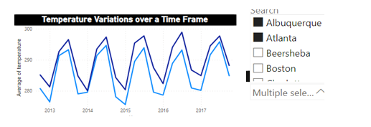

**EXPLANATION**

In the absence of specific energy consumption data for cities, the focus is on analyzing temperature trends over time. A consistent observation reveals a recurring wave-like pattern each year, suggesting a cyclical nature in temperature fluctuations. It's noteworthy that temperature and energy consumption typically exhibit a positive correlation. The analysis estimates that for every 1-degree increase in temperature, there is a proportional impact on electricity demand, driving it up by approximately 6.7% in the region. This correlation underscores the interconnectedness between temperature variations and energy consumption, emphasizing the significance of understanding these trends for effective energy management and resource planning.

**PROBLEM STATEMENT-**

How do specific wind patterns impact air quality and pollution dispersion in urban areas? Analyze wind direction data for insights? (Q-13)

To Analyse this particular Problem, we need to have the data regarding air quality and air pollution dispersion in the cities. But, as of now we don’t have the data regarding that. If the required data is available, we would have made a meaningful insight.

**VISUAL REPRESENTATION**

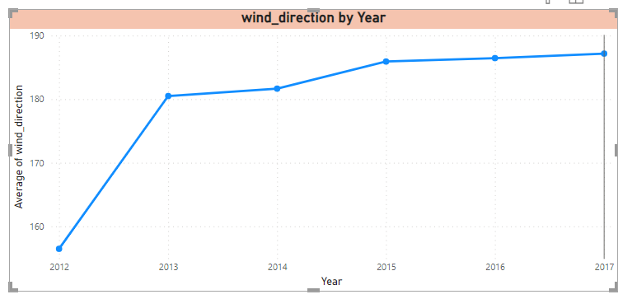

**EXPLANATION**

Upon conducting an analysis of wind direction over the years, a discernible trend emerges, indicating a gradual increase in wind speeds annually. This pattern has significant implications, particularly in the context of air quality and pollution dispersion within cities.

The observed rise in wind direction suggests an enhanced capacity for air movement and dispersion of pollutants. As wind speed increases, pollutants in the air are more likely to be dispersed, contributing to improved air quality in urban areas. However, this trend also raises considerations for potential challenges, such as increased dispersion of pollutants, which could impact air quality in downwind areas. Understanding this evolving wind direction pattern is crucial for urban planning, environmental management, and public health initiatives. It provides valuable insights for policymakers and city planners to develop effective strategies for mitigating air pollution and enhancing overall air quality, considering the dynamic nature of wind patterns over the years.

**PROBLEM STATEMENT-**

Identify cities prone to strong winds and the potential consequences, such as increased risk of natural disasters or challenges for transportation? (Q-14)

The Statement is to find the cities with strong winds that can cause and increase in natural disasters and also which will cause the challenges for transportation. So, as per my understanding there is no direct data related to it. I would like to assume as the following conditions will be act as near synonyms.

MIST, THUNDERSTROM, DUST, SLEET, DRIZZLE, SQUALLS, TORNADO, OVERCAST CLOUDS

**SQL QUERY**

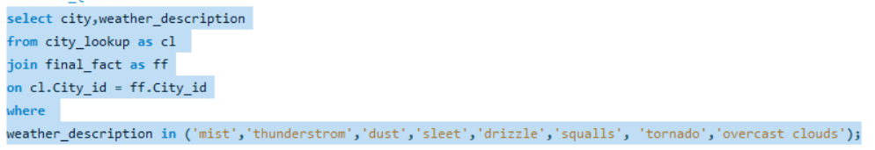

**VISUAL REPRESENTATION**

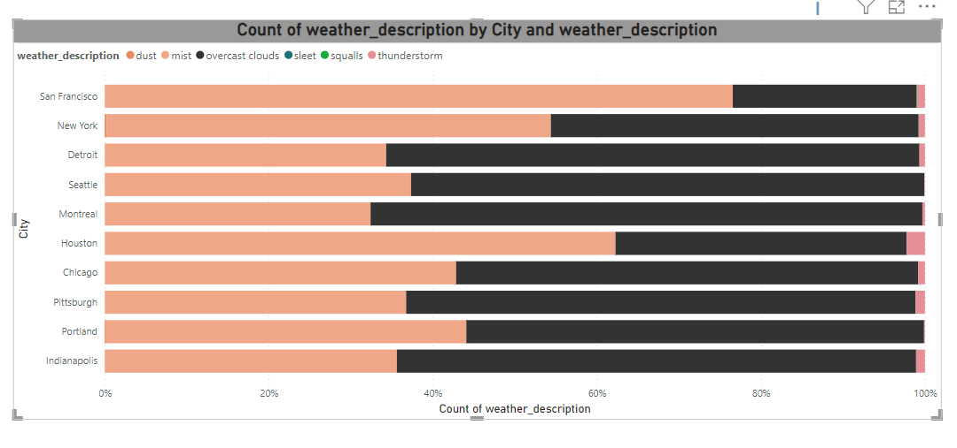

**EXPLANATION**

Cities identified with a higher likelihood of being susceptible to strong winds may face potential consequences, including an elevated risk of natural disasters and heightened challenges for transportation. The heightened vulnerability to strong winds underscores the need for these cities to be prepared for adverse weather events, as powerful winds can contribute to various impactful scenarios.

In terms of natural disasters, cities prone to strong winds may experience an increased risk of events such as hurricanes, tornadoes, or severe storms. These weather phenomena can lead to significant property damage, disruptions in essential services, and pose threats to public safety.

Additionally, transportation systems in these cities may encounter challenges due to strong winds. Issues such as flight cancellations, road closures, and disruptions in public transit can occur, affecting the daily mobility of residents and posing logistical challenges for businesses and emergency services.

City planners, emergency management agencies, and transportation authorities in these areas should prioritize comprehensive planning and preparedness measures to mitigate the potential consequences associated with strong winds. This includes infrastructure improvements, early warning systems, and public awareness campaigns to enhance resilience and reduce the impact of adverse weather events on these susceptible cities.

**PROBLEM STATEMENT**

Explore whether wind speed and direction influence the frequency and severity of weather-related events (e.g., hurricanes, storms) in coastal cities.

As there is no direct word as Hurricanes or storms in the data, I would like to consider the Following as Synonyms for them.

1. Broken Clouds
2. Scattered Clouds,
3. Ragged thunderstorm
4. Squalls
5. Tornado

**SQL QUERY**

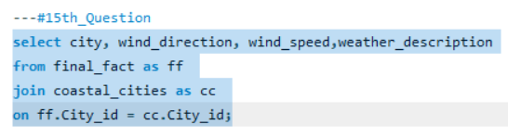

**VISUAL REPRESENTATION**

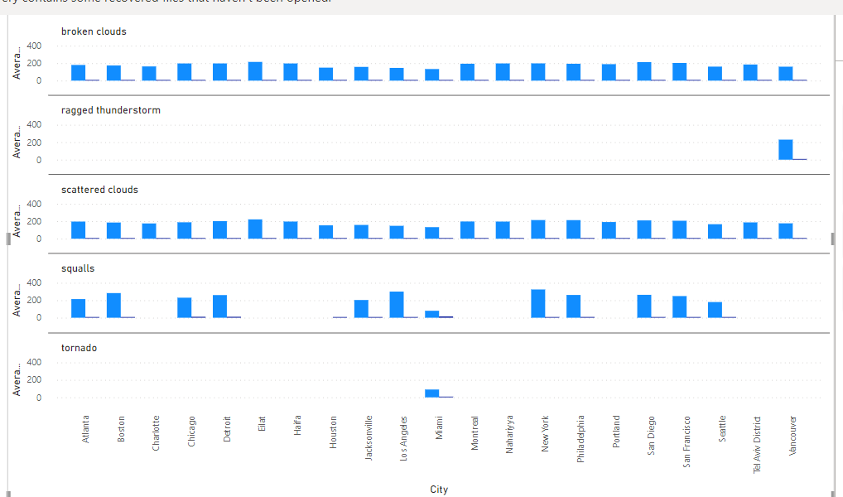

**EXPLANATION**

The visual analysis indicates a direct correlation between the severity of weather-related events and the interplay of wind direction and speed in coastal cities. Coastal areas, positioned at the land-sea interface with extensive inland regions, are inherently more vulnerable. The visual pattern suggests that an increase in wind speed or a change in wind direction amplifies the severity of weather events, particularly hurricanes and storms. This vulnerability stems from the geographical exposure of coastal cities to dynamic atmospheric conditions over large water bodies. In summary, heightened wind dynamics in coastal regions correlate with increased severity of weather-related events, emphasizing the need for proactive measures to enhance resilience in these areas.